**Q 1.**



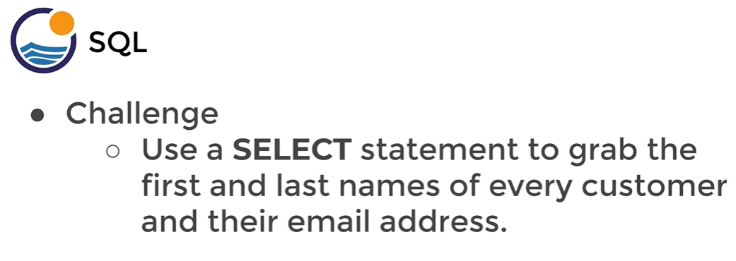

**Q 2.**

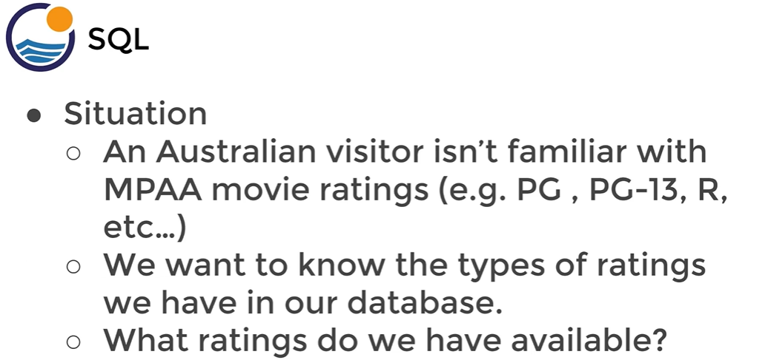

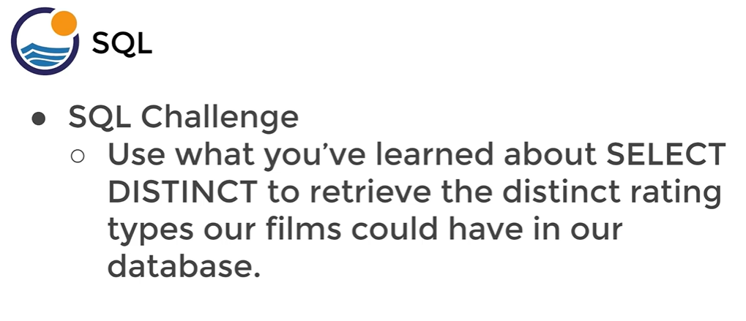

**Q 3.** How many recordsavailable for payments

How many unique amount has done for payments.

**Q 4.**

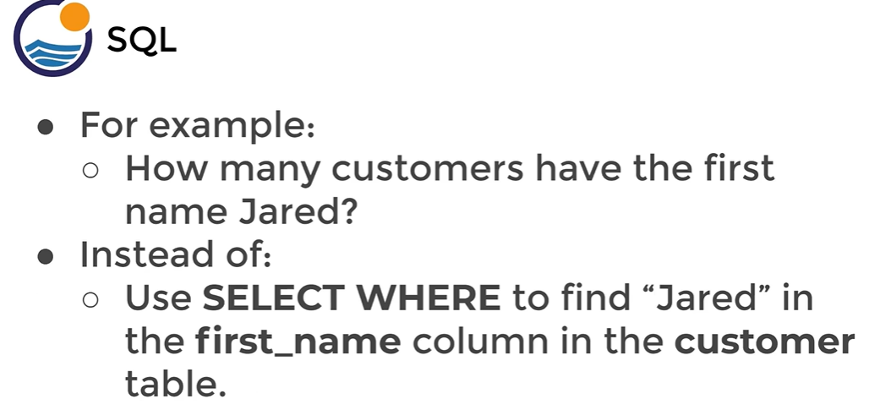

**Q 5.**

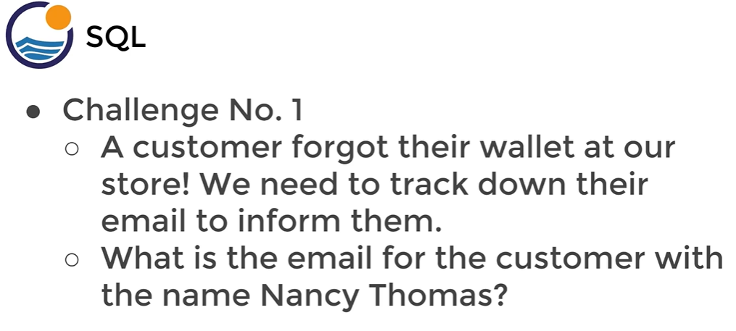

**Q 6.**

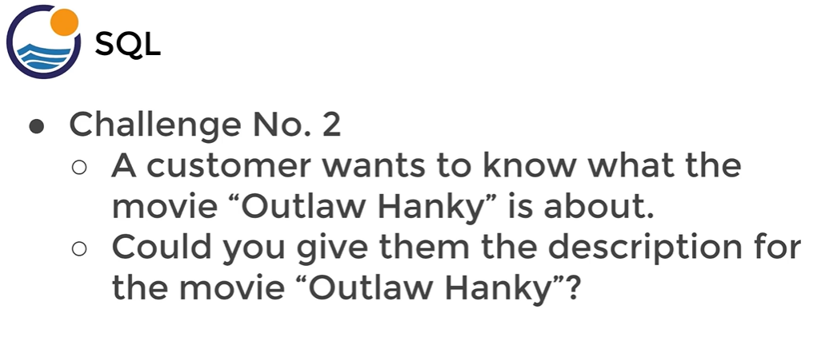

**Q 7.**

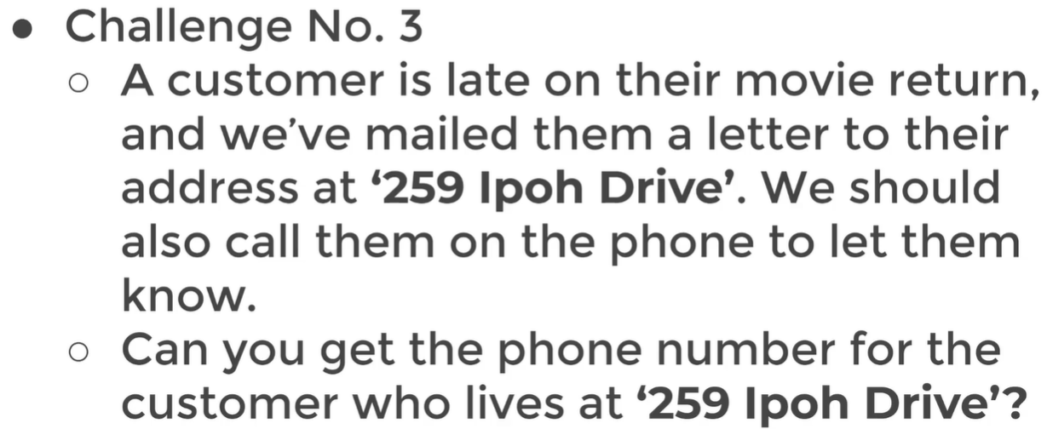

**Q 8.**

What is the 10 most recent purchases in the Payment table.

**Q 9.**

What if u just want to see a Layout of the table.

**Q 10.**

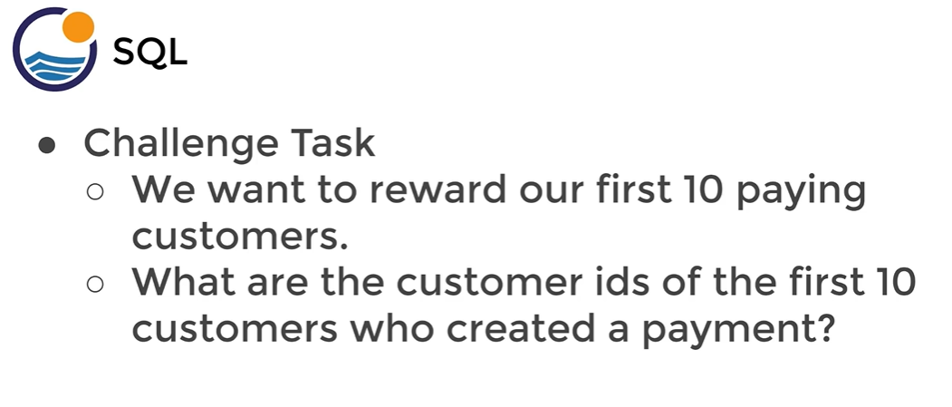

**Q 11.**

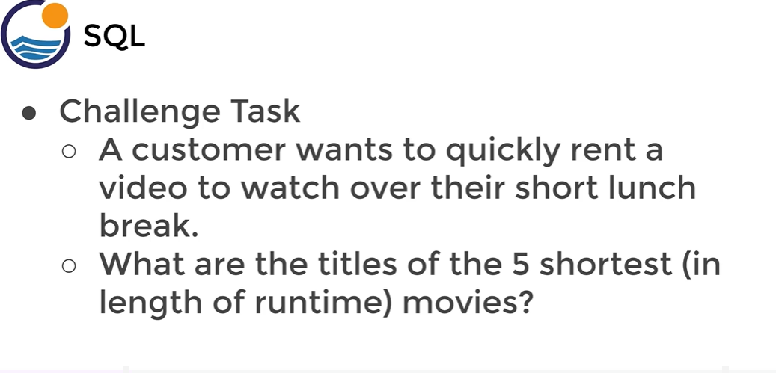

**Q 12.**

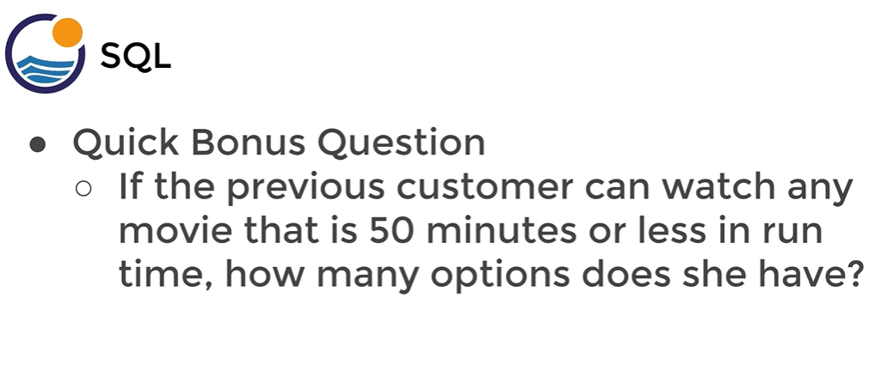

**Q 13.**

Find the amount between 4 and 5 which payment has been done.

**Q 14.**

Find all the Payments done from 15th Feb 2007 to 20th Feb 2007(It excludes the last date I mean max no.)

**Q 15.**

Find the list of payments whose amount is between 4 to 6 and that payments has not been done in February and March.

**Q 16.**

Find the number of customers who has done the payments of the list of amount in 0.99,1,98 and 1.99

**Q 17.**

Find the name of the customers where customers are not in the list of John Jake and Julie.

**Q 18.**

How many customers whose actually name starts with J. ( **LIKE** is case Sensitive)

**Q 19.**

Find the customers whose actually name starts with j and last name starts with s . ( **ILIKE** is case In- Sensitive)

**Q 20.**

Find the person who is having **er** somewhere in the name.

**Q21.**

Find the people whose first name starts with A but last name doesn’t starts with B.

**Q 22.**

How many payment transactions were greater than $5.00?

**Q 23.**

How many actors have a first name that starts with a letter P?

**Q 24.**

How many unique districts are our customers from?

**Q 25.**

Retrieve the list of names for those distinct districts from the previous question?

**Q 26.**

How many films have a rating of R and a replacement cost between $5 and $15?

**Q 27.**

How many films have the word Truman somewhere in the title?

**Q 28.**

What is the minimum replacement cost for a movie which got released?

**Q 29.**

What is the most expensive movie?

**Q 30.**

Find out the minimum and maximum cost of a film?

**Q 31.**

Find the average replacement cost of a film? (It will gives you a lot of significant digits)

In realistically we don’t want significant digits of a decimal points, so we can wrap using **ROUND**

**Q 32.**

Find the average replacement cost of a film in 2 decimal significant digits?

**Q 33.**

Find the total sum of the replacement_cost of all the films?

GROUP BY we can use on a column where repetition of a value is there for a particular column.

**Q 34.**

What customer id is spending more amount of money? (Payment table)

**Q 35.**

What customer id is done more number of transactions?

**Q 36.**

Show an example of a GROUP BY of multiple column for payment table?

**Q 37.**

Find the total amount of transaction per day?

**Q 38.**

We have two staff members with Staff IDs 1 and 2. We want to give a bonus to the staff member that handled the most payments. (Most in terms of number of payments processed, not total dollar amount).

How many payments did each staff member handle and who gets the bonus?

**Q 39.**

Corporate HQ is conducting a study on the relationship between replacement cost and movie MPAA rating (e.g. G, PG, R etc…)

What is the average replacement cost per MPAA rating?

Note: you may need to expand the AVG column to view correct results.

**Q 40.**

We are running a promotion to reward our top 5 customers with coupons.

What are the customer ids of the top 5 customers by total spend?

The HAVING clause allows us to filter **after** an aggregationhas already taken place.

**Q 41.**

What are the customer ids of the customers whose total spend is more than 200?

**Q 42.**

Find the number of customers per store?

**Q 43.**

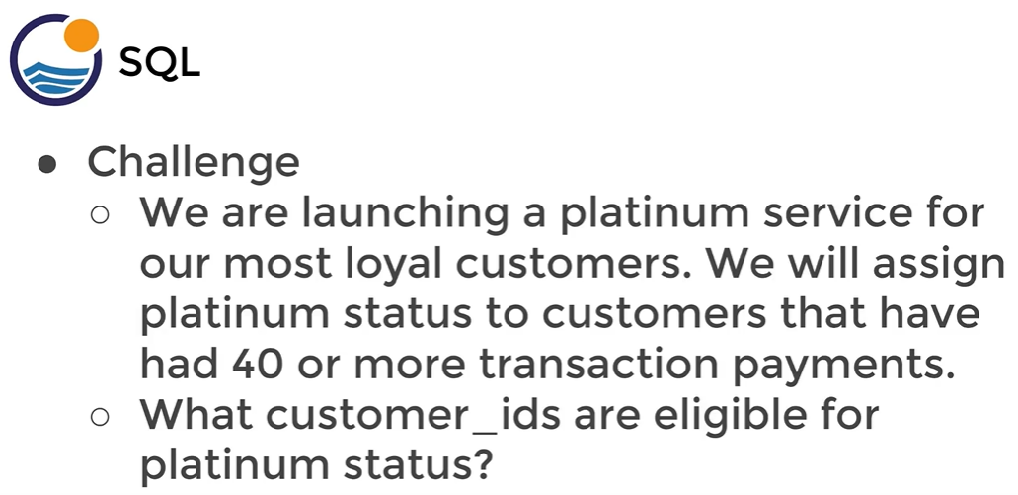

**Q 44.**

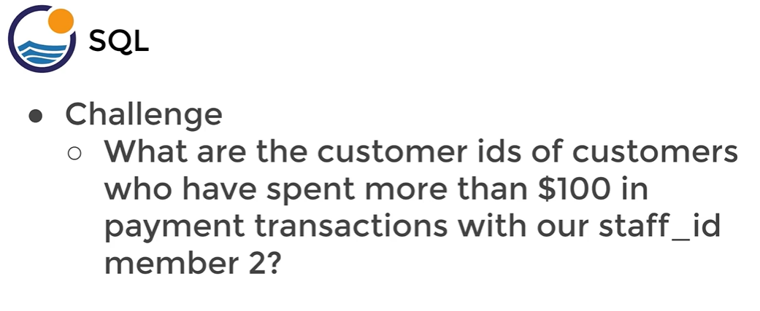

**Q 45.**

Return the customer IDs of customers who have spent at least $110 with the staff member who has an ID of 2.

**Q 46.**

How many films begin with the letter J?

**Q 47.**

What customer has the highest customer ID number whose name starts **with** an 'E' **and**has an address ID lower than 500?

**Q 48.**

How much each customer actually has spent?

**Q 49.**

California sales tax laws have changes, and we need to alert our customers to do this through emails.

What are the emails of the customers who live in California?

**Q50.**

A customer walks in and is a huge fan of the actor “Nick Wahlberg” and wants to know which movies he is in.

Get A list of all the movies “Nick Wahlberg” has been in.

**Answer-**

1. SELECT first_name, last_name, email

FROM customer

1. SELECT

DISTINCT rating

FROM film

1. SELECT

COUNT(*)

FROM payment

SELECT

COUNT(DISTINCT amount)

FROM payment

1. SELECT COUNT(*)

FROM customer

WHERE first_name='Jared'

1. SELECT email

FROM customer

WHERE first_name='Nancy' AND last_name='Thomas'

1. SELECT description

FROM film

WHERE title='Outlaw Hanky'

1. SELECT phone

FROM address

WHERE address = '259 Ipoh Drive'

1. SELECT *

FROM payment

WHERE amount != 0.00

ORDER BY payment_date DESC

LIMIT 10

1. SELECT *

FROM payment

LIMIT 1;

1. SELECT customer_id

FROM payment

ORDER BY payment_date ASC

LIMIT 10

1. SELECT title, length

FROM film

ORDER BY length ASC

LIMIT 5

1. SELECT COUNT(*)

FROM film

WHERE length <= 50

1. SELECT *

FROM payment

WHERE amount

BETWEEN 4 AND 5

ORDER BY amount DESC

1. SELECT *

FROM payment

WHERE payment_date

BETWEEN '2007-02-15' AND '2007-02-20'

ORDER BY payment_date DESC

1. SELECT *

FROM payment

WHERE amount BETWEEN 4 AND 6

AND payment_date NOT BETWEEN '2007-02-01' AND '2007-03-31'

1. SELECT COUNT(*)

FROM payment

WHERE amount IN(0.99,1.98,1.99)

1. SELECT *

FROM customer

WHERE first_name NOT IN ('John','Jake','Julie')

1. SELECT COUNT(*)

FROM customer

WHERE first_name LIKE 'J%'

1. SELECT *

FROM customer

WHERE first_name ILIKE 'J%'

AND last_name ILIKE 's%'

1. SELECT *

FROM customer

WHERE first_name LIKE '%er%'

1. SELECT *

FROM customer

WHERE first_name LIKE 'A%'

AND last_name NOT LIKE 'B%'

ORDER BY last_name

1. SELECT COUNT(*)

FROM payment

WHERE amount > 5.00

1. SELECT COUNT(*)

FROM actor

WHERE first_name LIKE 'P%'

1. SELECT COUNT(DISTINCT(district))

FROM address

1. SELECT DISTINCT(district)

FROM address

1. SELECT COUNT(*)

FROM film

WHERE rating = 'R'

AND replacement_cost BETWEEN 5 AND 15

1. SELECT COUNT(*)

FROM film

WHERE title LIKE '%Truman%'

1. SELECT MIN(replacement_cost)

FROM film

1. SELECT MAX(replacement_cost)

FROM film

1. SELECT MIN(replacement_cost),MAX(replacement_cost)

FROM film

1. SELECT AVG(replacement_cost)

FROM film

1. SELECT ROUND(AVG(replacement_cost),2)

FROM film

1. SELECT SUM(replacement_cost)

FROM film

1. SELECT customer_id, SUM(amount)

FROM payment

GROUP BY customer_id

ORDER BY SUM(amount) DESC

1. SELECT customer_id, COUNT(amount)

FROM payment

GROUP BY customer_id

ORDER BY COUNT(amount) DESC

1. SELECT customer_id, staff_id, SUM(amount)

FROM payment

GROUP BY customer_id,staff_id

ORDER BY customer_id

SELECT customer_id, staff_id, SUM(amount)

FROM payment

GROUP BY customer_id,staff_id

ORDER BY SUM(amount) DESC

1. SELECT DATE(payment_date), SUM(amount)

FROM payment

GROUP BY DATE(payment_date)

ORDER BY SUM(amount) DESC

1. SELECT staff_id, COUNT(*)

FROM payment

WHERE staff_id IN(1,2)

GROUP BY staff_id

ORDER BY COUNT(amount) DESC

1. SELECT rating, ROUND(AVG(replacement_cost),2)

FROM film

GROUP BY rating

1. SELECT customer_id, SUM(amount)

FROM payment

GROUP BY customer_id

ORDER BY SUM(amount) DESC

LIMIT 5

1. SELECT customer_id, SUM(amount)

FROM payment

GROUP BY customer_id

HAVING SUM(amount) > 200

1. SELECT store_id, COUNT(customer_id)

FROM customer

GROUP BY store_id

HAVING COUNT(customer_id) > 300

1. SELECT customer_id, count(*)

FROM payment

GROUP BY customer_id

HAVING count(*)>=40

1. SELECT customer_id, SUM(amount)

FROM payment

WHERE staff_id = 2

GROUP BY customer_id

HAVING SUM(amount) > 100

1. SELECT customer_id, SUM(amount)

FROM payment

WHERE staff_id = 2

GROUP BY customer_id

HAVING SUM(amount) > 110

1. SELECT COUNT(*)

FROM film

WHERE title LIKE 'J%'

1. SELECT first_name, last_name

FROM customer

WHERE first_name LIKE 'E%'

AND address_id < 500

ORDER BY customer_id DESC

LIMIT 1

1. SELECT customer_id, SUM(amount) AS total_spent

FROM payment

GROUP BY customer_id

1. select district, email

FROM customer

INNER JOIN address

ON customer.address_id = address.address_id

WHERE address.district = 'California'